

**department of Computer Engineering & Applications**

**Institute of Engineering & Technology**

Lab Manual

**Subject Name & Code: OPERATING SYSTEM LAB**

**(BCAC 0818)**

**Course: BCA**

**Faculty’s Name: Dr. Anuj Mangal**

**Dr. Anil Kumar Chanchal**

**Ms. Paromita Goswami**

**Mr. Anuj Kumar**

**Mr. Santosh Swarnkar**

**Mr. Jayati Krishna Goswami**

**Ms. Cheshtaa Bhardwaj**

**Mr. Ankit Prakash**

**Year: II Semester: III Session: 2024-25**

**OPERATING SYSTEM LAB (BCAC 0818)**

# **Prerequisite:** Familiarity with programming constructs

**Credits: 02 Semester III L–T–P : 0–0–2**

|  |  |  |
| --- | --- | --- |
| **Prac. No.** | **Program** | **Page No.** |
| **1** | **Case Study On Open Standard and Software**: Introduction to Linux operating system and Preparing for Installation – Installation Checklist, Hardware Requirements, Partitioning, Installation problems, Working with the System, Shells and Utilities, Linux commands, File Handling using vi editor, Getting familiar with shell scripts. | **4** |
| **2** | Implement the following basic commands (with options) used in UNIX/LINUX OS: a) cp b) mv c) sort d) cut e) who f) whoami g) ps  h) kill i) bc j) top k) grep l) chmod | **8** |
| **3** | Implement the following basic commands (with options) used in UNIX/LINUX OS: a) ls b) mkdir c) cd d) cat e) man f) date g) cal h) rm i) rmdir j) head k) tail l) pwd | **13** |
| **4** | Write a shell script to find whether a number is even or odd. | **20** |
| **5** | Write a shell script to check if the number entered at the command line is  prime or not. | **21** |
| **6** | Write a shell script to input the name of a file as command line argument and display whether it is a file, a directory or anything else. | **22** |
| **7** | Write a menu driven shell script, which will print the following menu and execute the given task.   * Display a calendar of current month * Display today’s date and time. * Display username those are currently logged in the system. * Display your name at the given x,y position. * Display your terminal number. | **23** |
| **8** | Write a shell script to accept a login name. If not, a valid login name display message – “Entered login name is invalid”. | **25** |
| **9** | Write a shell script to compare two files and if found equal asks the user to delete the duplicate file. | **26** |
| **10** | Write a shell script to check whether the file have all the permissions or not. | **28** |
| **11** | Write a shell script to input the marks of a student in three subjects and determine their grade. | **29** |
| **12** | Write a shell script to display the Fibonacci series up to a specified limit n. | **31** |
| **13** | Write a shell script to display the multiplication table for a given number. | **32** |
| **14** | Write a shell script to reverse the number entered by the user. | **33** |
| **15** | Write a shell script to determine whether a given number is an Armstrong number. | **34** |
| **16** | Write a shell script to print a half-pyramid pattern using numbers. | **36** |
| **17** | Simulate FCFS CPU scheduling algorithm using shell script. | **37** |
| **18** | Simulate SJF CPU scheduling algorithm using shell script. | **39** |
| **19** | Simulate Priority CPU scheduling algorithm using shell script. | **43** |
| **20** | Simulate Round Robin CPU scheduling algorithm using shell script. | **46** |
| **21** | Simulate FIFO page replacement algorithm using shell script. | **48** |
| **22** | Simulate LRU page replacement algorithm using shell script. | **51** |

**Case Study on Open Standard and Software**:

Introduction to Linux operating system and Preparing for Installation – Installation Checklist, Hardware Requirements, Partitioning, Installation problems, Working with the System, Shells and Utilities, Linux commands, File Handling using vi editor, Getting familiar with shell scripts.

**1. Introduction to Linux Operating System**

Linux is an open-source operating system that follows the principles of open standards. It provides users and developers with the freedom to modify, distribute, and use the software without proprietary restrictions. Linux is widely adopted in various domains such as servers, desktops, and embedded systems due to its flexibility, security, and cost-effectiveness.

**2. Preparing for Installation**

To ensure a smooth installation process for Linux, careful preparation is required. The preparation steps involve checking hardware compatibility, understanding partitioning schemes, and following a checklist to avoid potential problems.

**3. Installation Checklist**

Before installing Linux, ensure that the following items are in place:

* **Backup of important data**: Ensure that all important data on the computer is backed up.
* **Linux distribution**: Select and download the appropriate Linux distribution (e.g., Ubuntu, Fedora, CentOS).
* **Create a bootable USB**: Use tools like Rufus or UNetbootin to create a bootable USB drive for installation.
* **Check hardware compatibility**: Ensure that the system's hardware supports the selected Linux distribution.
* **Partitioning scheme**: Plan how to partition the hard disk. Linux generally needs at least a root ("/") partition and a swap partition.

**4. Hardware Requirements**

While Linux can run on a wide range of hardware, it is important to verify the minimum system requirements for the chosen distribution.

* **Minimum hardware requirements**:
  + Processor: 1 GHz (x86 or x86_64)
  + RAM: 1 GB for lightweight distributions, 2-4 GB for mainstream ones (e.g., Ubuntu, Fedora)
  + Hard Disk: Minimum 20 GB
  + Display: VGA capable of 1024x768 screen resolution

**5. Partitioning**

Linux allows for flexible partitioning schemes. It is recommended to use the following partitions:

* **Root ("/")**: This is where the operating system files are stored.
* **Swap**: This is used for virtual memory. Its size is typically 1.5 times the system's RAM.
* **Home ("/home")**: This partition stores user data and settings.
* **Optional partitions**: You may choose to have separate partitions for /boot or /var for better system management.

**6. Installation Problems**

Common installation problems include:

* **Boot issues**: The system might fail to boot if the bootloader (GRUB) is not properly configured.
* **Partitioning errors**: Incorrect partitioning can result in data loss or installation failure.
* **Driver issues**: Some hardware components (e.g., Wi-Fi, graphics cards) may not be supported out of the box.

To address these issues, ensure that you:

* **Check documentation**: Review the distribution's installation guide.
* **Test live environments**: Use a live USB session to test the hardware before installation.
* **Update drivers**: Download the necessary drivers from the manufacturer if required.

**7. Working with the System**

Once Linux is installed, familiarize yourself with the desktop environment (e.g., GNOME, KDE, or Xfce) and package management tools (e.g., apt, yum, or dnf) to install software.

* **Package management**: Use commands like sudo apt install <package> (Debian-based) or sudo dnf install <package> (Fedora-based) to install software.

**8. Shells and Utilities**

Linux provides powerful shell environments like Bash, Zsh, and others. Shells allow users to interact with the system through command-line utilities. Important shell utilities include:

* **Navigating directories**: cd, ls
* **Copying and moving files**: cp, mv
* **Displaying file contents**: cat, less

**9. Linux Commands**

Some essential Linux commands for system management include:

* **System management**:
  + sudo: Execute commands with superuser privileges.
  + df -h: Show disk space usage.
  + free -m: Display memory usage.
* **File management**:
  + touch <filename>: Create a new file.
  + rm <filename>: Remove a file.
  + chmod: Change file permissions.

**10. File Handling using vi Editor**

The **vi editor** is a powerful text editor in Linux. Basic vi commands include:

* **Entering vi**: vi <filename>
* **Insert mode**: Press i to start editing the file.
* **Save and exit**: Press Esc followed by :wq to save and exit.

**11. Getting Familiar with Shell Scripts**

Shell scripting automates tasks in Linux. A simple shell script example:

#!/bin/bash

echo "Hello, World!"

To run the script, save it as script.sh, then execute the following:

chmod +x script.sh

./script.sh

Shell scripts can handle loops, conditions, and functions, making them ideal for automating tasks like backups, file management, or system monitoring.

**Conclusion**

Linux, with its open standards and vast capabilities, is a robust operating system suited for diverse computing needs. Understanding the installation process, commands, and scripting enhances productivity and efficiency in managing Linux systems.

**EXPERIMENT NO: 2**

**Environment:** Ubuntu

**Objective:** Implement the following basic commands (with options) used in UNIX/LINUX OS: a) cp b) mv c) sort d) cut e) who f) whoami g) ps h) kill i) bc j) top k) grep l) chmod

**Layout :**

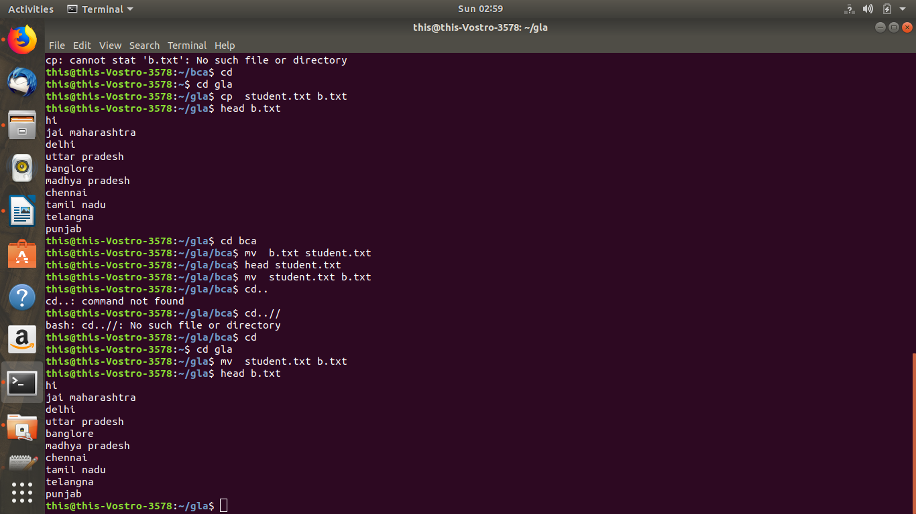

**Procedure:**

**1. cp**

DESCRIPTION-

cp - copy files and directories

SYNTAX-

* cp <first file name><second file name>

**2. mv**

DESCRIPTION-

Rename SOURCE to DEST, or move SOURCE(s) to DIRECTORY.

SYNTAX-

* mv <file_name1><file_name2>



**3. sort**

DESCRIPTION-

Write sorted concatenation of all FILE(s) to standard output.

SYNTAX-

* sort <file_name>
* sort -n <file_name>
* sort -r <file_name>

**4. cut**

DESCRIPTION-

cut - remove sections from each line of files

SYNTAX-

* cut -b <file_name>
* cut -c <file_name>kill - send a signal to a process

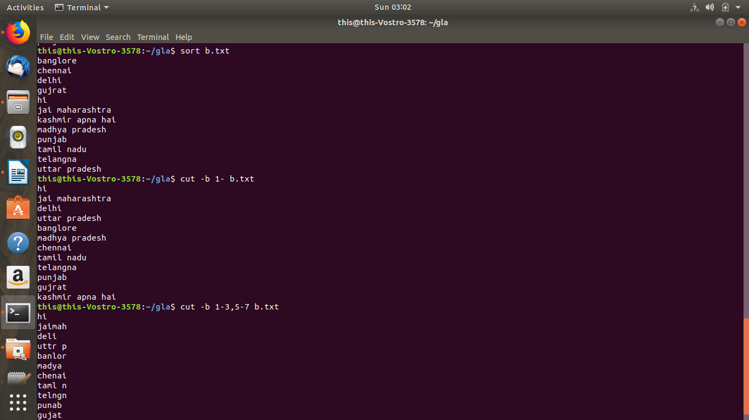

**5. who**

DESCRIPTION-

show who is logged on

SYNTAX-

* who

**6. whoami**

DESCRIPTION-

print effective userid

SYNTAX-

* whoami

**7. ps**

DESCRIPTION-

report a snapshot of the current processes.

SYNTAX-

* ps

**8. kill**

DESCRIPTION-

kill - send a signal to a process to kill.

SYNTAX-

* kill <process_id>

**9. bc**

DESCRIPTION-

An arbitrary precision calculator language.

SYNTAX-

* bc

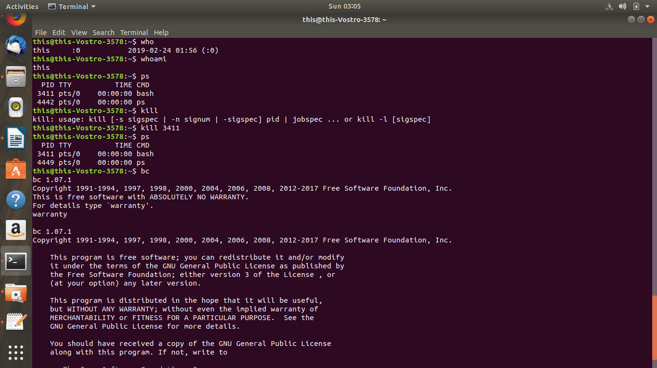

**10. top**

DESCRIPTION-

top - display Linux processes

SYNTAX-

* top

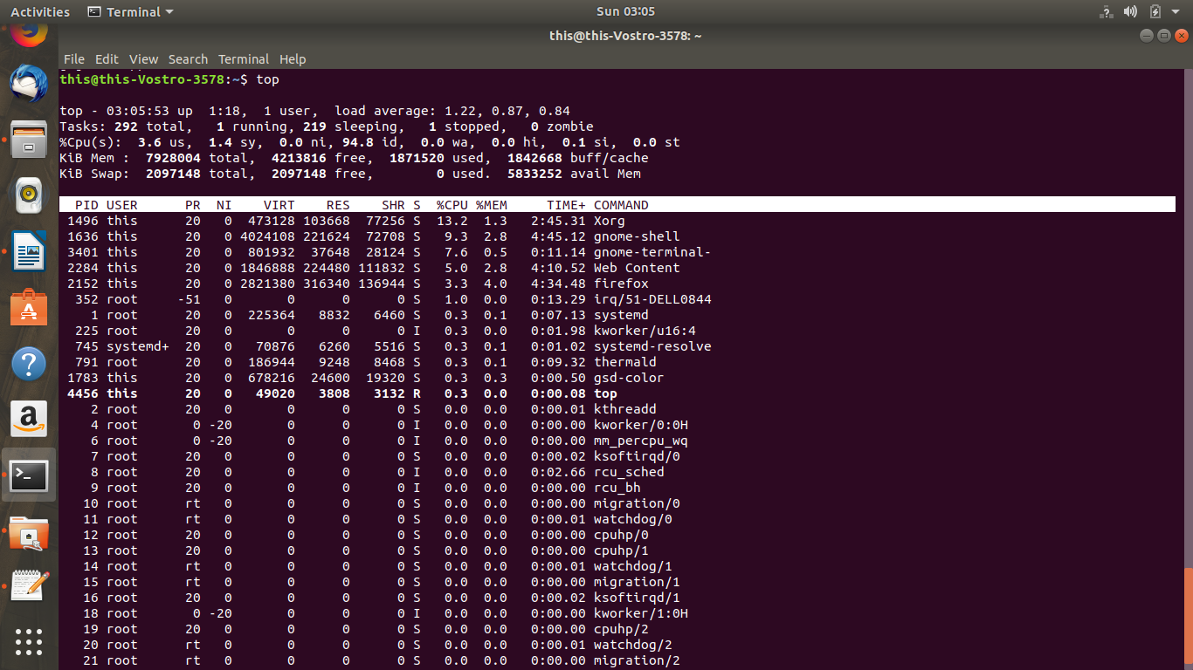

**11. grep**

DESCRIPTION-

print lines matching a pattern

SYNTAX-

* grep

**12. chmod**

DESCRIPTION-

change file mode bits.

SYNTAX-

* chmod -x <file_name>

chmod -w <file_name>

**EXPERIMENT NO: 3**

**Environment:** Ubuntu

**Objective:** Implement the following basic commands (with options) used in UNIX/LINUX OS: a) ls b) mkdir c) cd d) cat e) man f) date g) cal h) rm i) rmdir j) head k) tail l) pwd

**Layout:**

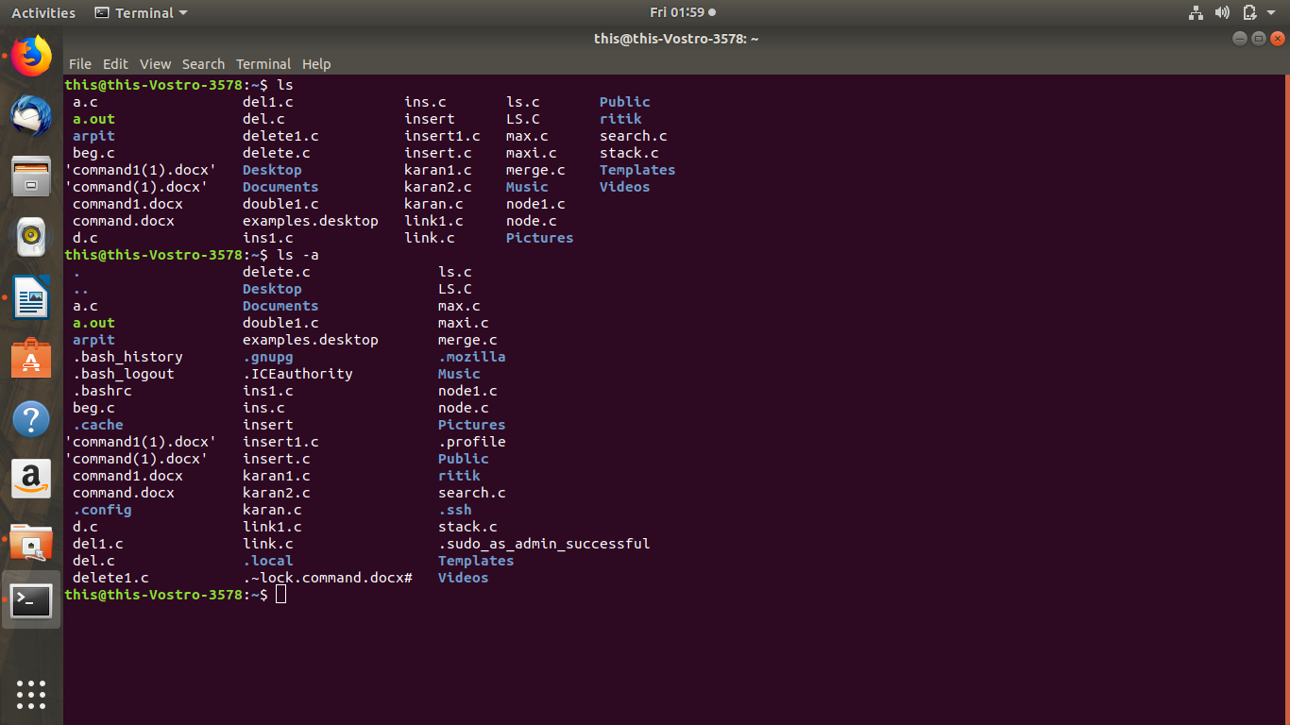

**Procedure:**

**1. ls**

DESCRIPTION-

List information about the FILEs (the current directory by default).

Sort entries alphabetically if none of -cftuvSUX nor --sort is specified.

SYNTAX-

* ls
* ls -a
* ls -A
* ls -s
* ls -t
* ls -r
* ls -lh
* ls -lrt



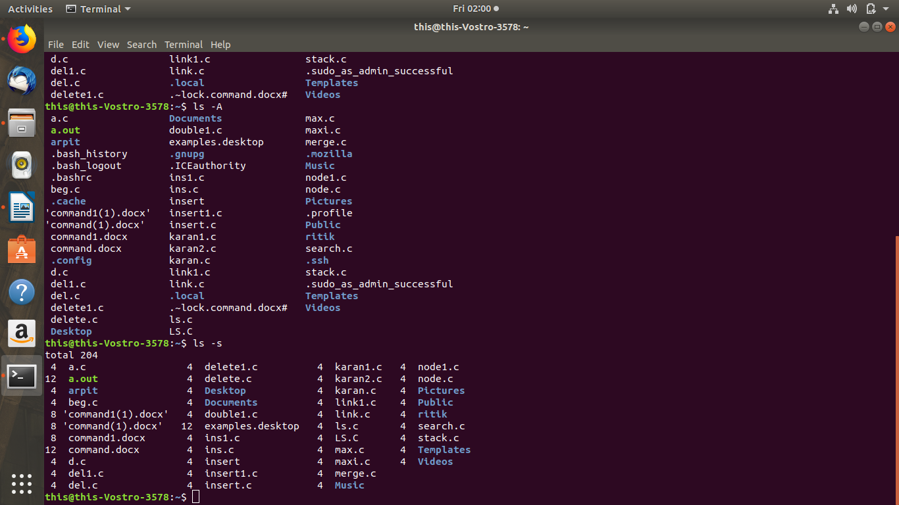

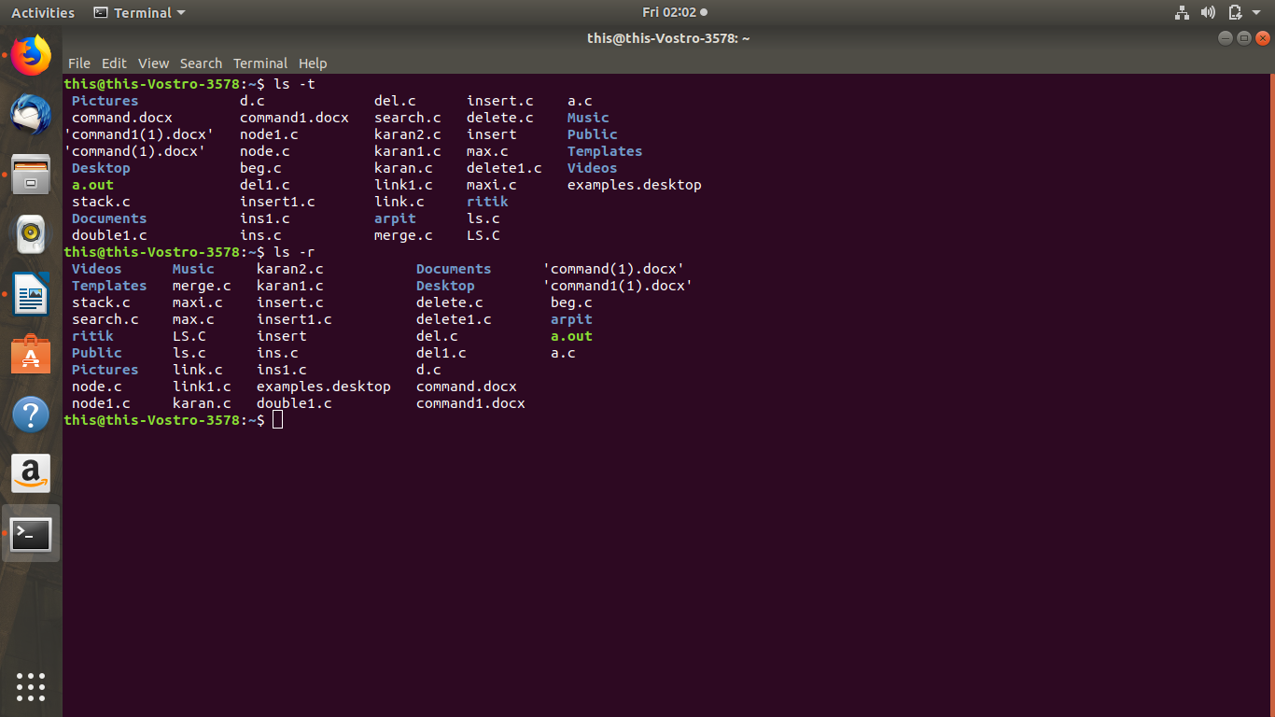

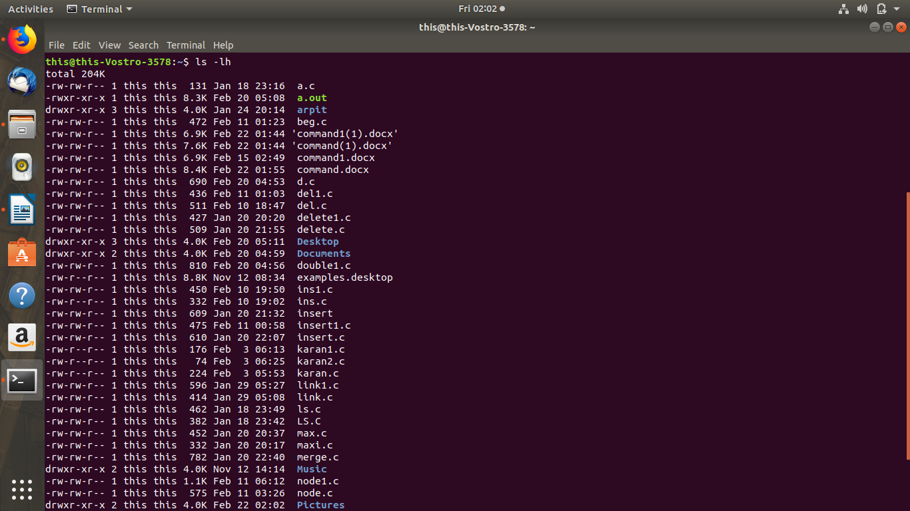

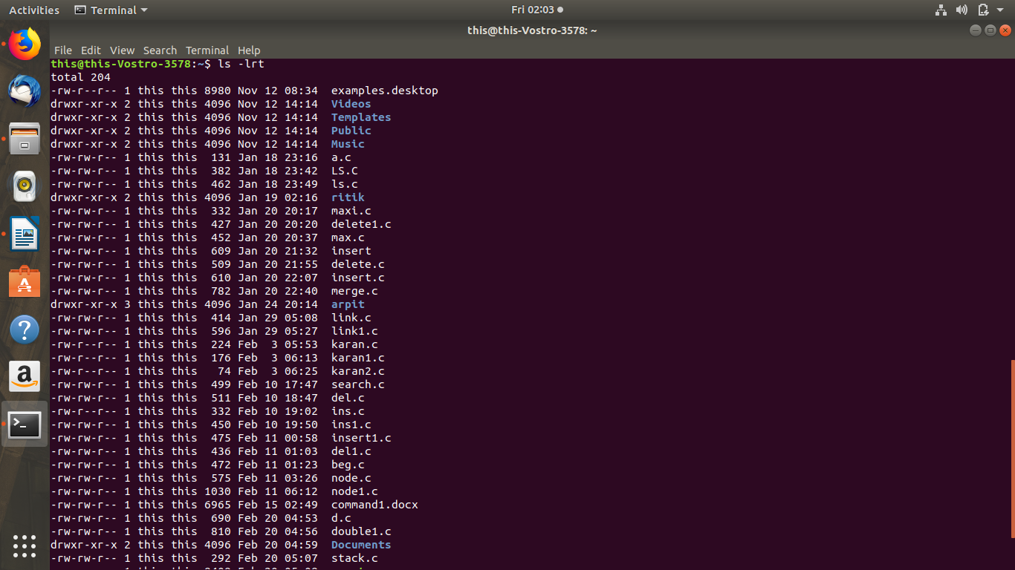

**2. mkdir**

DESCRIPTION-

Create the DIRECTORY(ies), if they do not already exist.

SYNTAX-

* mkdir <directory_name>

**3. cd**

DESCRIPTION-

It changes your working directory. Use it to move around within

the hierarchy of your file system.

SYNTAX-

* cd
* cd <directory_name>
* cd..
* cd../..

**4. cat**

DESCRIPTION-

Concatenate FILE(s) to standard output.

SYNTAX-

* cat <file_name>
* cat ><file_name>
* cat <file_name1>><file_name2>

**5. man**

DESCRIPTION-

man - an interface to the on-line reference manuals

SYNTAX-

* man <command>

**6. date**

DESCRIPTION-

date - print or set the system date and time

SYNTAX-

* date
* date -d

**7. cal**

DESCRIPTION-

cal, ncal — displays a calendar and the date of Easter

SYNTAX-

* cal

**8. rm**

DESCRIPTION-

rm - remove files or directories

SYNTAX-

* rm <file_name>
* rm <directory_name>

**9. rmdir**

DESCRIPTION-

rmdir - remove empty directories

SYNTAX-

* rmdir <directory_name>

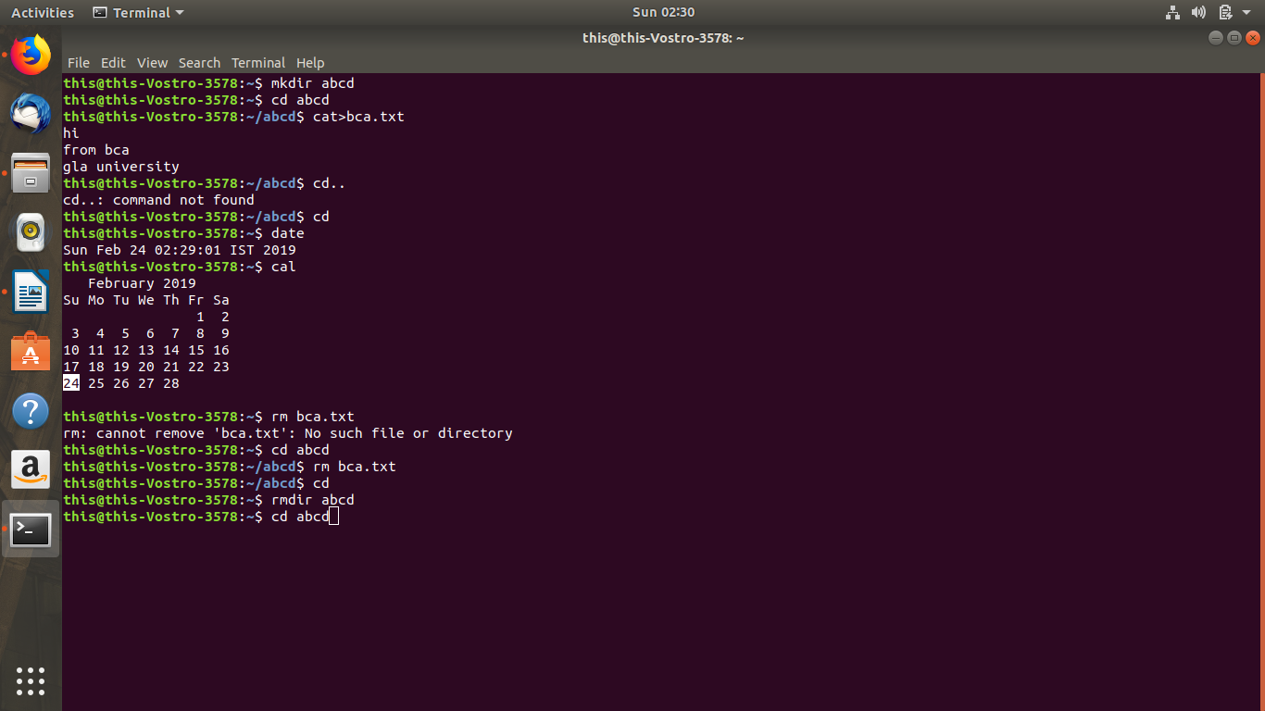

**10. head**

DESCRIPTION-

head - output the first part of files

SYNTAX-

* head <file_name>

**11. tail**

DESCRIPTION-

tail - output the last part of files

SYNTAX-

* tail <file_name>

**12. pwd**

DESCRIPTION-

pwd - print name of current/working directory

SYNTAX-

* pwd

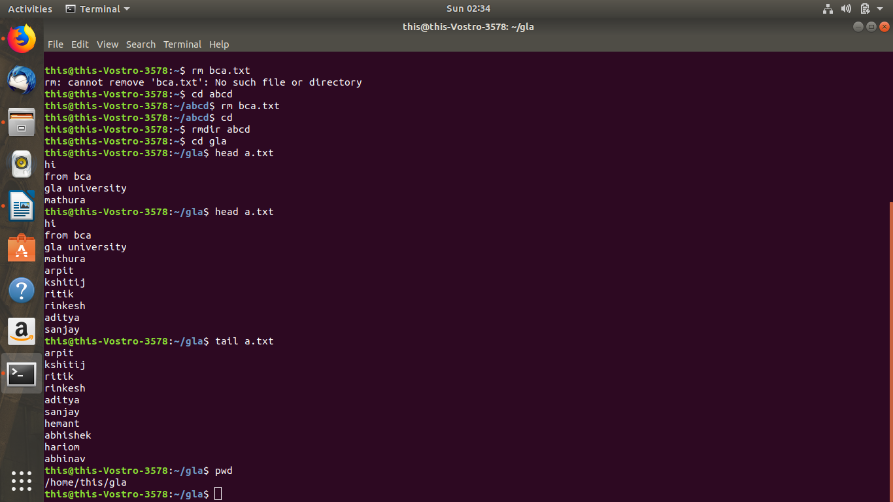

**EXPERIMENT NO: 4**

**Environment:** Ubuntu

**Objective:**  **Write a shell script to find whether a number is even or odd.**

**Layout:**

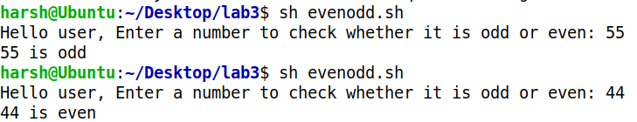

**Procedure:**

#!/bin/bash

read -p "Hello user, Enter a number to check whether it is odd or even: " num

if [ "$(expr $num % 2)" -eq 0 ]

then

echo "$num is even"

else

echo "$num is odd"

fi

**EXPERIMENT NO: 5**

**Environment:** Ubuntu

**Objective:** Write a shell script to check if the number entered at the command line is

prime or not.

**Layout:**

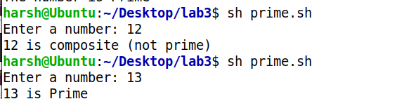

**Procedure:**

#!/bin/bash

read -p "Enter a number: " num

i=2

f=0

while [ $i -le `expr $num / 2` ]

do

if [ `expr $num % $i` -eq 0 ]

then

f=1

fi

i=`expr $i + 1`

done

if [ $f -eq 1 ]

then

echo "$num is composite (not prime)"

else

echo "$num is Prime"

fi

**EXPERIMENT NO: 6**

**Environment:** Uuntu

**Objective:** Write a shell script to input the name of a file as command line argument and display whether it is a file, a directory or anything else.

**Layout:**



**Procedure:**

#!/bin/bash

Passed=$"abc.txt"

if [ -d "${Passed}" ]

then

echo "$ Passed is a directory";

else

if [ -f "${Passed}" ]

then

echo "$ Passed is a file";

else

echo "Unknown File"

echo $Passed

exit $[Passed]

fi

fi

**EXPERIMENT NO: 7**

**Environment:** Ubuntu

**Objective:** Write a menu driven shell script, which will print the following menu and execute the given task.

* Display a calendar of current month
* Display today’s date and time
* Display username those are currently logged in the system
* Display your name at the given x,y position.
* Display your terminal number.

**Layout:**

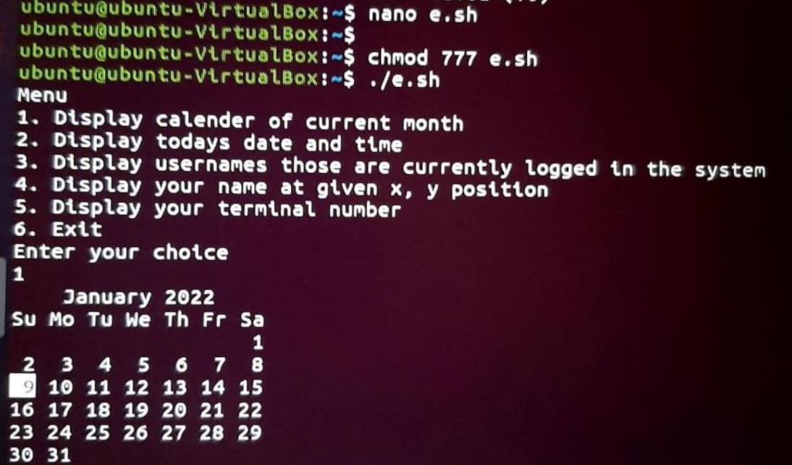

**Procedure:**

#!/bin/bash

echo "Menu"

echo "1. Display calender of current month " echo "2. Display

todays date and time"

echo "3. Display usernames those are currently logged in the system"

echo "4. Display your name at given x, y position" echo "5. Display your

terminal number"

echo "6. Exit"

echo "Enter your choice" read c

case $c in

1) **cal;;**2) **date;;**

3) **who;;**

4) **clear**

echo "Enter x, y position"

read x

read y

tput cup $x $y

whoami;;

**EXPERIMENT NO: 8**

**Environment:** Git Bash

**Objective:** Write a shell script to accept a login name. If not, a valid login name display message – “Entered login name is invalid”.

**Layout:**

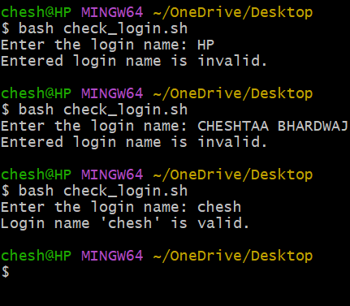

**Procedure:**

#!/bin/bash

# Prompt the user to enter a login name

read -p "Enter the login name: " login_name

# Check if the login name exists in the system

if id "$login_name" &>/dev/null; then

echo "Login name '$login_name' is valid."

else

echo "Entered login name is invalid."

fi

**EXPERIMENT NO: 9**

**Environment:** Git Bash

**Objective:** Write a shell script to compare two files and if found equal asks the user to delete the duplicate file.

**Layout:**

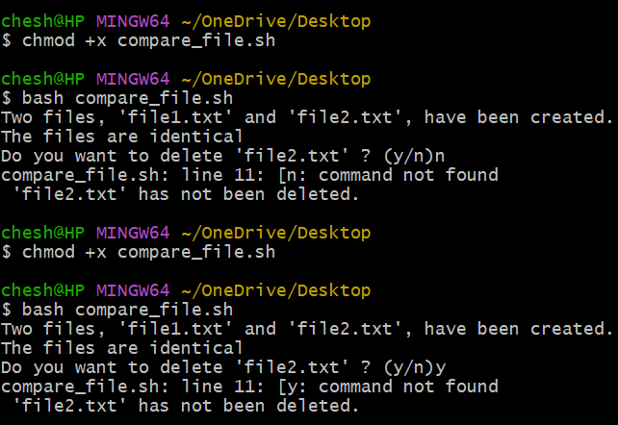

**Procedure:**

#!/bin/bash

echo " This is the first file." > file1.txt

echo " This is the first file." > file2.txt

echo "Two files, 'file1.txt' and 'file2.txt', have been created."

if cmp -s "file1.txt" "file2.txt"; then

echo "The files are identical"

read -p "Do you want to delete 'file2.txt' ? (y/n)" answer

if ["$answer" = "y" ]; then

rm "file2.txt"

echo " 'file2.txt' has been deleted."

else

echo " 'file2.txt' has not been deleted."

fi

else

echo " The files are different."

fi

**EXPERIMENT NO: 10**

**Environment:** Git Bash

**Objective:** Write a shell script to check whether the file have all the permissions or not.

**Layout:** 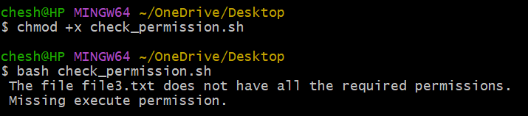

**Procedure:**

#!/bin/bash

echo " This is the third file"> file3.txt

file="file3.txt"

if [ ! -f "$file" ]; then

echo "The file '$file' does not exist."

exit 1

fi

if [ -r "$file" ] && [ -w "$file" ] && [ -x "$file" ]; then

echo " The file '$file' has read, write and execute permissions."

else

echo " The file $file does not have all the required permissions."

[ ! -r "$file" ] && echo " Missing read permission."

[ ! -w "$file" ] && echo " Missing write permission."

[ ! -x "$file" ] && echo " Missing execute permission."

fi

**EXPERIMENT NO: 11**

**Environment:** Ubuntu

**Objective:** Write a shell script to input the marks of a student in three subjects and determine their grade.

**Layout:**



**Procedure:**

#!/bin/bash

echo "-------------Marksheet---------------------"

echo "Enter Student's Details:"

echo "-----------------------------------"

echo "Enter Student's Name:"

read n1

echo "Enter Student's Roll No.:"

read n2

echo "Enter Marks of First Subject (Out Of 100):"

read s1

echo "Enter Marks of Second Subject (Out Of 100):"

read s2

echo "Enter Marks of Third Subject (Out Of 100):"

read s3

echo "Student's Name: $n1"

echo "Student's Roll No.: $n2"

echo "Marks of First Subject: $s1"

echo "Marks of Second Subject: $s2"

echo "Marks of Third Subject: $s3"

sum=$((s1+s2+s3));

echo "Student's Total Marks is: $sum (out of 300)";

per=$((sum*100/300))

echo "Student's Percentage is: $per%"

avg=$((sum/3));

if [ $avg -gt 91 ]&&[ $avg -lt 100 ]

then

echo "Student's Grade is A+";

else

if [ $avg -gt 81 ]&&[ $avg -lt 90 ]

then

echo "Student's Grade is A";

else

if [ $avg -gt 71 ]&&[ $avg -lt 80 ]

then

echo "Student's Grade is B+";

else

if [ $avg -gt 61 ]&&[ $avg -lt 70 ]

then

echo "Student's Grade is B";

else

if [ $avg -gt 51 ]&&[ $avg -lt 60 ]

then

echo "Student's Grade is C";

else

if [ $avg -gt 41 ]&&[ $avg -lt 50 ]

then

echo "Student's Grade is D";

else

echo "Student's Grade is F";

fi

fi

fi

fi

fi

fi

**EXPERIMENT NO: 12**

**Environment:** Ubuntu

**Objective:** Write a shell script to display the Fibonacci series up to a specified limit n.

**Layout:**



**Procedure:**

#!/bin/bash

echo "Enter the Number"

read n

x=0

y=1

i=1

echo "Fibonacci Series is"

echo "$x"

echo "$y"

while [ $i -le $((n-2)) ]

do

z=$(($x+$y))

echo "$z"

x=$y

y=$z

i=$(($i+1))

done

**EXPERIMENT NO: 13**

**Environment:** Ubuntu

**Objective:** Write a shell script to display the multiplication table for a given number.

**Layout:**

**Procedure:**

#!/bin/bash

echo "Enter the Number"

read n

i=1

while [ $i -le 10 ]

do

echo "$n*$i=$(($n*$i))"

i=$(($i+1))

done

**EXPERIMENT NO: 14**

**Environment:** Ubuntu

**Objective:** Write a shell script to reverse the number entered by the user.

**Layout**



**Procedure:**

#!/bin/bash

echo "Enter a number"

read n

s=0

x=$n

r=0

while [ $x -gt 0 ]

do

r=$(($x%10))

s=$(($s*10+$r))

x=$(($x/10))

done

echo "Reverse number is $s"

**EXPERIMENT NO: 15**

**Environment:** Ubuntu

**Objective:** Write a shell script to determine whether a given number is an Armstrong number.

**Layout:**



**Procedure:**

#!/bin/bash

echo "Enter a number"

read n

s=0

t=$n

p=0

a=0

while [ $n -gt 0 ]

do

a=$(($n % 10))

n=$(($n / 10))

p=$(($p+1))

done

n=$t

while [ $n -gt 0 ]

do

a=$(($n % 10))

n=$(($n / 10))

s=$(($s + $(($a**$p))))

done

if [ $s -eq $t ]

then

echo "NUMBER IS ARMSTRONG"

else

echo "NUMBER IS NOT ARMSTRONG"

fi Write a shell script to print half pyramid using numbers.

**EXPERIMENT NO: 16**

**Environment:** Ubuntu

**Objective:** Write a shell script to print a half-pyramid pattern using numbers.

**Layout:**

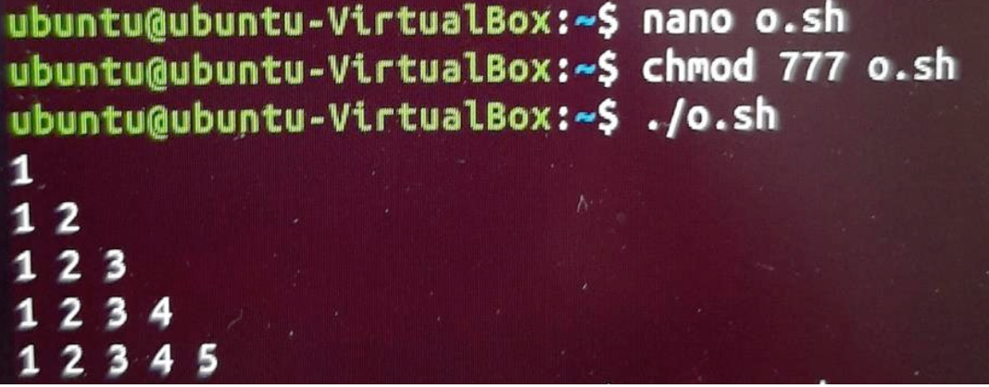

**Procedure:**

#!/bin/bash

number=1

rows=5

for((i=1; i<=rows; i++))

do

for((j=1; j<=i; j++))

do

echo -n "$number "

number=$((number + 1))

done

number=1

done

**EXPERIMENT NO: 17**

**Environment:** Git Bash

**Objective:** Simulate FCFS CPU scheduling algorithm using shell script.

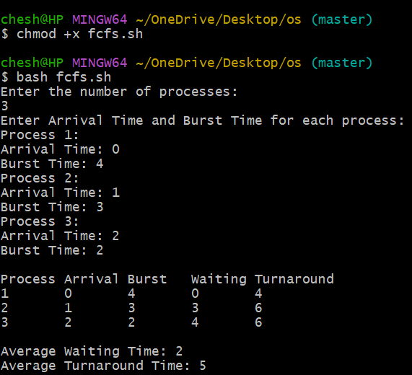**Layout:**

**Procedure:**

#!/bin/bash

# Get the number of processes

echo "Enter the number of processes:"

read n

# Declare arrays for storing process data

declare -a arrival_time

declare -a burst_time

declare -a waiting_time

declare -a turnaround_time

# Input arrival time and burst time for each process

echo "Enter Arrival Time and Burst Time for each process:"

for ((i = 0; i < n; i++)); do

echo "Process $((i+1)):"

echo -n "Arrival Time: "

read arrival_time[i]

echo -n "Burst Time: "

read burst_time[i]

done

# Initialize the first process's waiting and turnaround time

waiting_time[0]=0

turnaround_time[0]=${burst_time[0]}

# Calculate waiting time and turnaround time for each process

total_waiting=0

total_turnaround=${burst_time[0]}

for ((i = 1; i < n; i++)); do

# Waiting time is the time since the last process finished until this one starts

waiting_time[i]=$(( turnaround_time[i-1] - arrival_time[i] ))

# Ensure waiting time is non-negative (if the process arrives after the previous one finishes)

if [ ${waiting_time[i]} -lt 0 ]; then

waiting_time[i]=0

fi

# Turnaround time is waiting time + burst time

turnaround_time[i]=$(( waiting_time[i] + burst_time[i] ))

# Update total waiting and turnaround times

total_waiting=$(( total_waiting + waiting_time[i] ))

total_turnaround=$(( total_turnaround + turnaround_time[i] ))

done

# Output process times

echo -e "\nProcess\tArrival\tBurst\tWaiting\tTurnaround"

for ((i = 0; i < n; i++)); do

echo -e "$((i+1))\t${arrival_time[i]}\t${burst_time[i]}\t${waiting_time[i]}\t${turnaround_time[i]}"

done

# Calculate and print average waiting and turnaround times (integer division)

average_waiting=$(( total_waiting / n ))

average_turnaround=$(( total_turnaround / n ))

echo -e "\nAverage Waiting Time: $average_waiting"

echo "Average Turnaround Time: $average_turnaround"

**EXPERIMENT NO: 18**

**Environment:** Git Bash

**Objective:** Simulate SJF (Non-Pre-emptive) CPU scheduling algorithm using shell script.

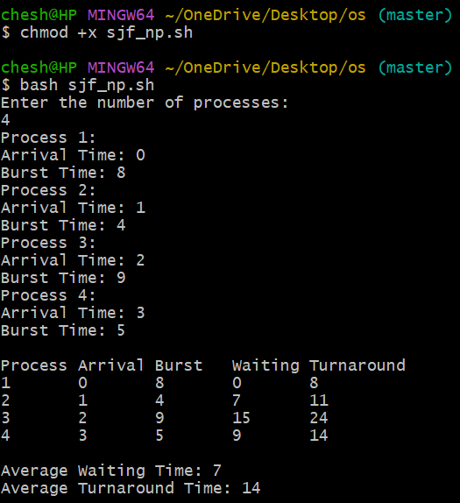**Layout:**

**Procedure:**

#!/bin/bash

# Get the number of processes

echo "Enter the number of processes:"

read n

# Declare arrays for storing process data

declare -a process_id

declare -a arrival_time

declare -a burst_time

declare -a waiting_time

declare -a turnaround_time

declare -a completion_time

# Input arrival time and burst time for each process

for ((i = 0; i < n; i++)); do

echo "Process $((i+1)):"

process_id[i]=$((i+1))

echo -n "Arrival Time: "

read arrival_time[i]

echo -n "Burst Time: "

read burst_time[i]

done

# Initialize current time and tracking arrays

current_time=0

completed=0

total_waiting=0

total_turnaround=0

is_completed=($(for ((i = 0; i < n; i++)); do echo 0; done)) # to mark process completion

# Main loop to simulate SJF non-preemptive scheduling

while [ $completed -ne $n ]; do

min_index=-1

min_burst=9999

# Find the process with the shortest burst time among those that have arrived

for ((i = 0; i < n; i++)); do

if [ ${arrival_time[i]} -le $current_time ] && [ ${is_completed[i]} -eq 0 ]; then

if [ ${burst_time[i]} -lt $min_burst ]; then

min_burst=${burst_time[i]}

min_index=$i

fi

fi

done

# If no process has arrived by the current time, increment the current time

if [ $min_index -eq -1 ]; then

current_time=$((current_time + 1))

else

# Process the selected job

current_time=$((current_time + ${burst_time[min_index]}))

completion_time[min_index]=$current_time

turnaround_time[min_index]=$((completion_time[min_index] - arrival_time[min_index]))

waiting_time[min_index]=$((turnaround_time[min_index] - burst_time[min_index]))

# Update totals and mark the process as completed

total_waiting=$((total_waiting + waiting_time[min_index]))

total_turnaround=$((total_turnaround + turnaround_time[min_index]))

is_completed[min_index]=1

completed=$((completed + 1))

fi

done

# Output process details

echo -e "\nProcess\tArrival\tBurst\tWaiting\tTurnaround"

for ((i = 0; i < n; i++)); do

echo -e "${process_id[i]}\t${arrival_time[i]}\t${burst_time[i]}\t${waiting_time[i]}\t${turnaround_time[i]}"

done

# Calculate and print average waiting and turnaround times

average_waiting=$(( total_waiting / n ))

average_turnaround=$(( total_turnaround / n ))

echo -e "\nAverage Waiting Time: $average_waiting"

echo "Average Turnaround Time: $average_turnaround"

**EXPERIMENT NO: 19**

**Environment:** Git Bash

**Objective:** Simulate SRTF CPU scheduling algorithm using shell script.

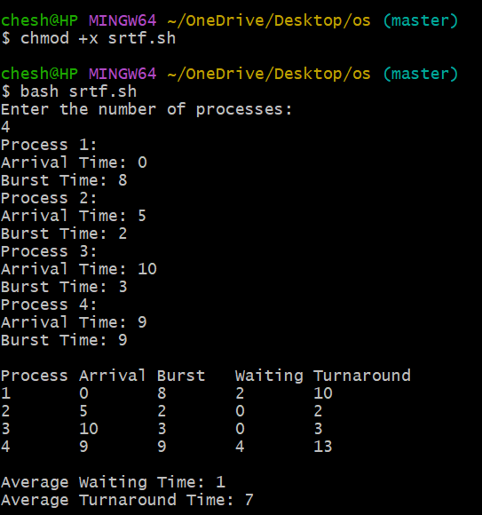**Layout:**

**Procedure:**

#!/bin/bash

# Get the number of processes

echo "Enter the number of processes:"

read n

# Declare arrays for storing process data

declare -a process_id

declare -a arrival_time

declare -a burst_time

declare -a remaining_time

declare -a waiting_time

declare -a turnaround_time

declare -a is_completed

# Input arrival time and burst time for each process

for ((i = 0; i < n; i++)); do

echo "Process $((i+1)):"

process_id[i]=$((i+1))

echo -n "Arrival Time: "

read arrival_time[i]

echo -n "Burst Time: "

read burst_time[i]

remaining_time[i]=${burst_time[i]} # Initialize remaining time with burst time

is_completed[i]=0 # Mark all processes as not completed initially

done

# Initialize time and total variables

current_time=0

completed=0

total_waiting=0

total_turnaround=0

min_remaining_time=9999

shortest=-1

finish_time=0

# Arrays to track whether a process is completed or not

completed_processes=0

# SRTF Simulation

while [ $completed -lt $n ]; do

# Find the process with the shortest remaining time that has arrived

for ((i = 0; i < n; i++)); do

if [ ${arrival_time[i]} -le $current_time ] && [ ${is_completed[i]} -eq 0 ] && [ ${remaining_time[i]} -lt $min_remaining_time ] && [ ${remaining_time[i]} -gt 0 ]; then

min_remaining_time=${remaining_time[i]}

shortest=$i

fi

done

# If no process is found, increment current time

if [ $shortest -eq -1 ]; then

current_time=$((current_time + 1))

continue

fi

# Reduce the remaining time of the shortest process

remaining_time[$shortest]=$((remaining_time[$shortest] - 1))

# Update the minimum remaining time

min_remaining_time=${remaining_time[$shortest]}

if [ ${remaining_time[$shortest]} -eq 0 ]; then

min_remaining_time=9999

fi

# If the process finishes, calculate completion, turnaround, and waiting times

if [ ${remaining_time[$shortest]} -eq 0 ]; then

completed=$((completed + 1))

finish_time=$current_time

is_completed[$shortest]=1

# Turnaround time = Finish time - Arrival time

turnaround_time[$shortest]=$((finish_time + 1 - arrival_time[$shortest]))

# Waiting time = Turnaround time - Burst time

waiting_time[$shortest]=$((turnaround_time[$shortest] - burst_time[$shortest]))

# Update total turnaround and waiting time

total_turnaround=$((total_turnaround + turnaround_time[$shortest]))

total_waiting=$((total_waiting + waiting_time[$shortest]))

fi

# Increment the current time

current_time=$((current_time + 1))

done

# Output process details

echo -e "\nProcess\tArrival\tBurst\tWaiting\tTurnaround"

for ((i = 0; i < n; i++)); do

echo -e "${process_id[i]}\t${arrival_time[i]}\t${burst_time[i]}\t${waiting_time[i]}\t${turnaround_time[i]}"

done

# Calculate and print average waiting and turnaround times

average_waiting=$(( total_waiting / n ))

average_turnaround=$(( total_turnaround / n ))

echo -e "\nAverage Waiting Time: $average_waiting"

echo "Average Turnaround Time: $average_turnaround"

**EXPERIMENT NO: 20**

**Environment:** Git Bash

**Objective:** Simulate RR CPU scheduling algorithm using shell script.

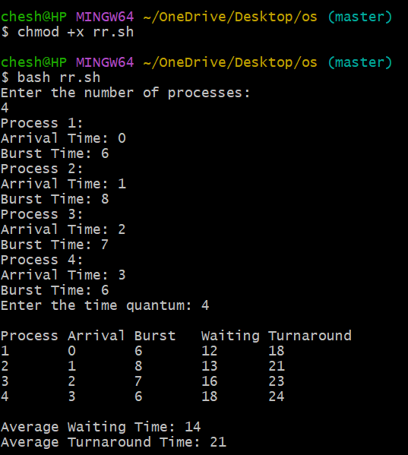**Layout:**

**Procedure:**

#!/bin/bash

# Get the number of processes

echo "Enter the number of processes:"

read n

# Declare arrays for storing process data

declare -a process_id

declare -a arrival_time

declare -a burst_time

declare -a remaining_time

declare -a waiting_time

declare -a turnaround_time

declare -a completion_time

# Input arrival time and burst time for each process

for ((i = 0; i < n; i++)); do

echo "Process $((i+1)):"

process_id[i]=$((i+1))

echo -n "Arrival Time: "

read arrival_time[i]

echo -n "Burst Time: "

read burst_time[i]

remaining_time[i]=${burst_time[i]} # Initialize remaining time with burst time

done

# Get time quantum

echo -n "Enter the time quantum: "

read time_quantum

# Initialize variables

current_time=0

total_waiting=0

total_turnaround=0

completed_processes=0

# Continue until all processes are completed

while [ $completed_processes -lt $n ]; do

for ((i = 0; i < n; i++)); do

if [ ${remaining_time[i]} -gt 0 ] && [ ${arrival_time[i]} -le $current_time ]; then

# Calculate execution time for this process

if [ ${remaining_time[i]} -le $time_quantum ]; then

current_time=$((current_time + remaining_time[i]))

turnaround_time[i]=$((current_time - arrival_time[i]))

waiting_time[i]=$((turnaround_time[i] - burst_time[i]))

remaining_time[i]=0

completed_processes=$((completed_processes + 1))

else

current_time=$((current_time + time_quantum))

remaining_time[i]=$((remaining_time[i] - time_quantum))

fi

fi

done

done

# Output process details

echo -e "\nProcess\tArrival\tBurst\tWaiting\tTurnaround"

for ((i = 0; i < n; i++)); do

echo -e "${process_id[i]}\t${arrival_time[i]}\t${burst_time[i]}\t${waiting_time[i]}\t${turnaround_time[i]}"

total_waiting=$((total_waiting + waiting_time[i]))

total_turnaround=$((total_turnaround + turnaround_time[i]))

done

# Calculate and print average waiting and turnaround times

average_waiting=$(( total_waiting / n ))

average_turnaround=$(( total_turnaround / n ))

echo -e "\nAverage Waiting Time: $average_waiting"

echo "Average Turnaround Time: $average_turnaround"

**EXPERIMENT NO: 21**

**Environment:** Git Bash

**Objective:** Simulate FIFO page replacement using shell script.

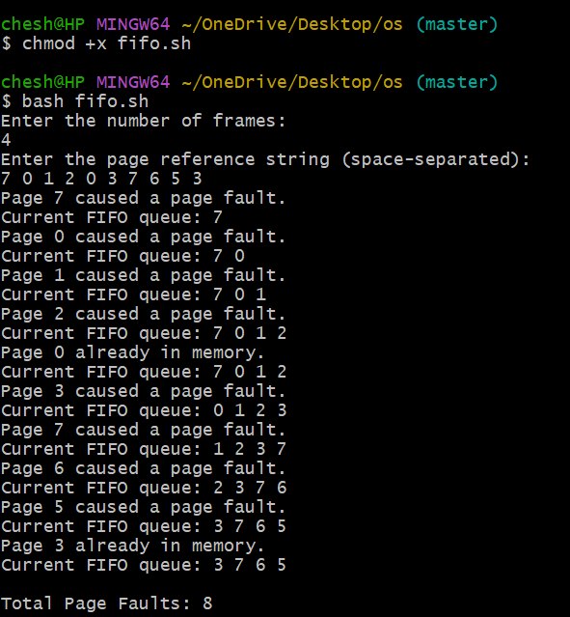**Layout:**

**Procedure:**

#!/bin/bash

# Get the number of frames (size of memory)

echo "Enter the number of frames:"

read frames

# Validate if frames is a positive integer

if ! [[ "$frames" =~ ^[0-9]+$ ]] || [ "$frames" -le 0 ]; then

echo "Invalid number of frames. Please enter a positive integer."

exit 1

fi

# Input the page reference string

echo "Enter the page reference string (space-separated):"

read -a page_references

# Initialize variables

page_faults=0

fifo_queue=()

# Iterate over each page reference

for page in "${page_references[@]}"; do

# Check if the page is already in the FIFO queue (memory)

found=0

for p in "${fifo_queue[@]}"; do

if [ "$p" -eq "$page" ]; then

found=1

break

fi

done

if [ $found -eq 0 ]; then

# Page fault occurs

page_faults=$((page_faults + 1))

echo "Page $page caused a page fault."

# If the FIFO queue is full, remove the oldest page

if [ ${#fifo_queue[@]} -ge $frames ]; then

oldest_page=${fifo_queue[0]}

fifo_queue=("${fifo_queue[@]:1}") # Remove the oldest page

fi

# Add the new page to the FIFO queue

fifo_queue+=("$page")

else

echo "Page $page already in memory."

fi

# Print the current state of the FIFO queue

echo -n "Current FIFO queue: "

for p in "${fifo_queue[@]}"; do

echo -n "$p "

done

echo

done

# Output the total number of page faults

echo -e "\nTotal Page Faults: $page_faults"

**EXPERIMENT NO: 22**

**Environment:** Git Bash

**Objective:** Simulate LRU page replacement using shell script.

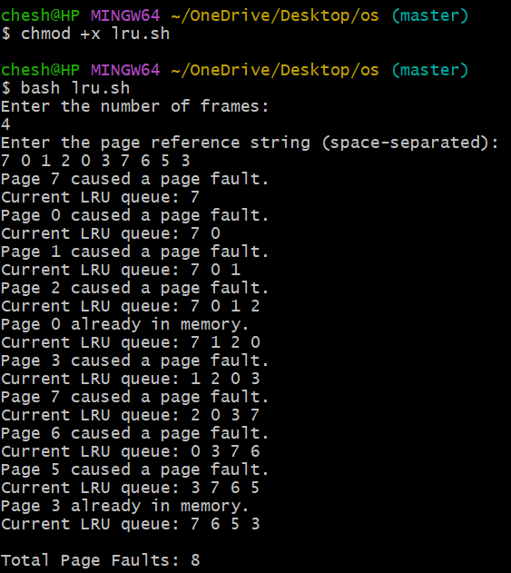**Layout:**

**Procedure:**

#!/bin/bash

# Get the number of frames (size of memory)

echo "Enter the number of frames:"

read frames

# Validate if frames is a positive integer

if ! [[ "$frames" =~ ^[0-9]+$ ]] || [ "$frames" -le 0 ]; then

echo "Invalid number of frames. Please enter a positive integer."

exit 1

fi

# Input the page reference string

echo "Enter the page reference string (space-separated):"

read -a page_references

# Initialize variables

page_faults=0

lru_queue=()

page_usage=()

# Iterate over each page reference

for page in "${page_references[@]}"; do

# Check if the page is already in the LRU queue (memory)

found=0

for i in "${!lru_queue[@]}"; do

if [ "${lru_queue[$i]}" -eq "$page" ]; then

found=1

# Move the page to the end of the queue to mark it as recently used

lru_queue=("${lru_queue[@]:0:$i}" "${lru_queue[@]:$((i + 1))}")

lru_queue+=("$page")

break

fi

done

if [ $found -eq 0 ]; then

# Page fault occurs

page_faults=$((page_faults + 1))

echo "Page $page caused a page fault."

# If the LRU queue is full, remove the least recently used page

if [ ${#lru_queue[@]} -ge $frames ]; then

lru_queue=("${lru_queue[@]:1}")

fi

# Add the new page to the LRU queue

lru_queue+=("$page")

else

echo "Page $page already in memory."

fi

# Print the current state of the LRU queue

echo -n "Current LRU queue: "

for p in "${lru_queue[@]}"; do

echo -n "$p "

done

echo

done

# Output the total number of page faults

echo -e "\nTotal Page Faults: $page_faults"

**\*\*THE END\*\***